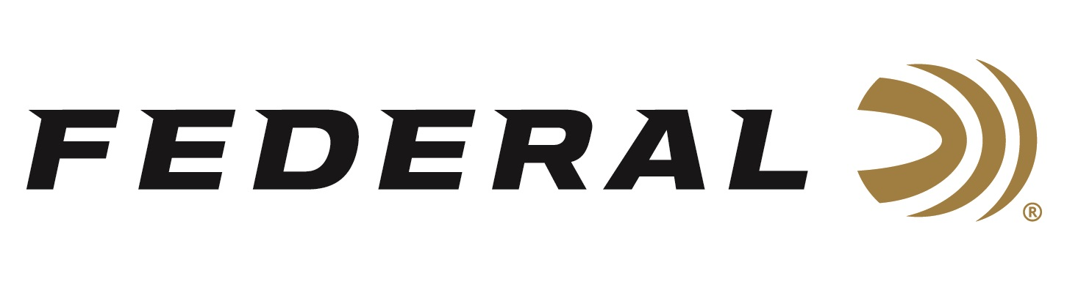

FOR IMMEDIATE RELEASE

Federal Ammunition Shooters win Men’s and Women’s Skeet Titles

ANOKA, Minnesota – May 25, 2023 – Skeet sensations Vincent Hancock and Austen Smith claimed gold medals at the 2023 Shotgun National Championships, qualifying them for the World Championship and Pan American Games. The nationals are part one of the Olympic selection process and the three-time gold medalist Hancock and previous Olympian Smith are seeking a spot on the 2024 U.S. team. The event was held May 19-22 at the John A. Halter Shooting Sports Center Complex in Hillsdale, Michigan.

Hancock finished third in the Open Men’s Skeet event missing just four targets before heading into the finals and ultimately defeating Conner Prince in a sudden death shoot-off. “I was very happy with my overall performance at this year’s National Championships,” said 3-time Olympic champion Vincent Hancock. “I struggled a little on days 3 and 4, but ultimately, I was able to make some adjustments before the Final and walk away with Gold. I’m thankful to have Federal Premium Ammunition on my side because, as always, my Federal Papers were powdering targets!”

Austen Smith, a twenty-two-year college student from Dallas, TX who is studying aerospace engineering, dropped just one target in the last five rounds of the Open Women’s Skeet competition. With that win, Smith was selected to represent the U.S. on the women’s skeet team that will be competing in Chile and Baku, Azerbaijan for the Pan American Games and World Championship.

“Amazing performances by Vincent and Austen,” said Federal Ammunition’s Vice President of Marketing, Jason Nash. “We are excited to watch these Olympic veterans and Paris hopefuls continue their journey to represent the United States.”

Federal is the number one choice for shotgun shells and manufactures product in America for all competitive and recreational disciplines. See the full lineup, including the latest High Over All, at www.federalpremium.com.

Federal ammunition can be found at dealers nationwide. For more information on all products from Federal or to shop online, visit www.federalpremium.com.

Press Release Contact: JJ Reich
Senior Manager – Press Relations
E-mail: VistaPressroom@VistaOutdoor.com

About Federal Ammunition
Federal, headquartered in Anoka, MN, is a brand of Vista Outdoor Inc., an outdoor sports and recreation company. From humble beginnings nestled among the lakes and woods of Minnesota, Federal Ammunition has evolved into one of the world's largest producers of sporting ammunition. Beginning in 1922, founding president, Charles L. Horn, paved the way for our success. Today, Federal carries on Horn's vision for quality products and service with the next generation of outdoorsmen and women. We maintain our position as experts in the science of ammunition production. Every day we manufacture products to enhance our customers' shooting experience while partnering with the conservation organizations that protect and support our outdoor heritage. We offer thousands of options in our Federal Premium and Federal® lines-it's what makes us the most complete ammunition company in the business and provides our customers with a choice no matter their pursuit.

